**DATA CLEANING :**

df['Item Fat Content']=df['Item Fat Content'].replace({'LF':'Low Fat',

'low fat':'Low Fat',

'reg':'Regular'})

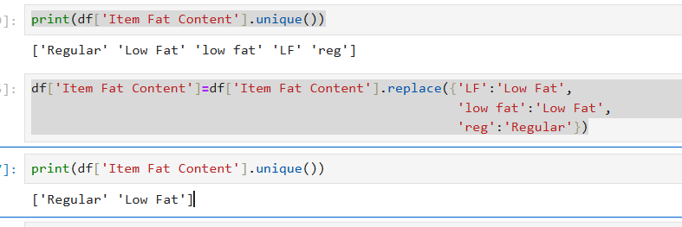

**REQUIREMENTS**

**1)TOTAL SALES:**

TOTAL_SALES=df['Sales'].sum()

print(f"TOTAL SALES: ${TOTAL_SALES:,.1f}")

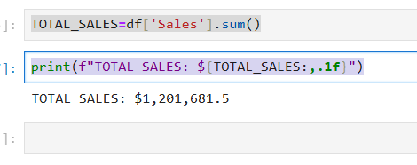

**2)AVERAGE SALES:**

AVG_SALES=df['Sales'].mean()

print(f"AVERAGE SALES: ${AVG_SALES:,.0f}")

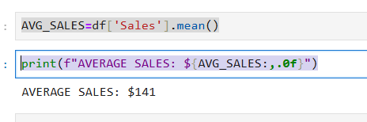

**3)NO OF ITEMS SOLD:**

Total_items_sold=df['Sales'].count()

print(f"NO OF ITEMS SOLD: {Total_items_sold:,.0f}")

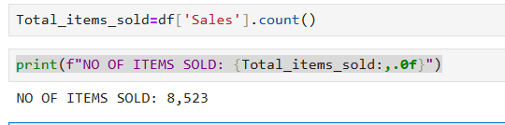

**4)AVERAGE RATING:**

AVG_RATING=df['Rating'].mean()

print(f"AVERAGE RATING: {AVG_RATING:,.1f}")

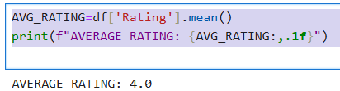

**5)TOTAL SALES BASED ON FAT CONTENT:**

def sum_value(val):

total=sum(total_sales_based_on_fatcontent)

sumvalue=int(round(val*total/100))

return f"${sumvalue:,}"

plt.pie(total_sales_based_on_fatcontent,labels=total_sales_based_on_fatcontent.index,

autopct=sum_value,

startangle=90)

plt.axis('equal')

plt.title('SALES BASED ON FAT CONTENT')

plt.show()

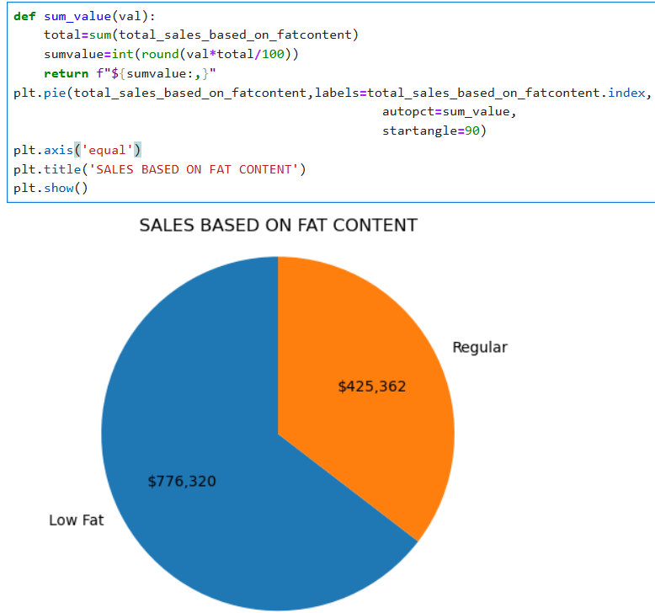

**6)TOTAL SALES BASED ON ITEM TYPE:**

TOTAL_SALES_BASED_ON_ITEMTYPE=df.groupby('Item Type')['Sales'].sum().sort_values(ascending=False)

plt.figure(figsize=(10,6))

bars=plt.bar(TOTAL_SALES_BASED_ON_ITEMTYPE.index,TOTAL_SALES_BASED_ON_ITEMTYPE.values)

plt.xticks(rotation=-90)

plt.xlabel('Item Type')

plt.ylabel('Sales')

plt.title('TOTAL SALES BASED ON ITEM TYPE')

for bar in bars:

plt.text(

bar.get_x() + bar.get_width() / 2,

bar.get_height(),

f'{bar.get_height():,.0f}',

ha='center',

va='bottom',

fontsize=8

)

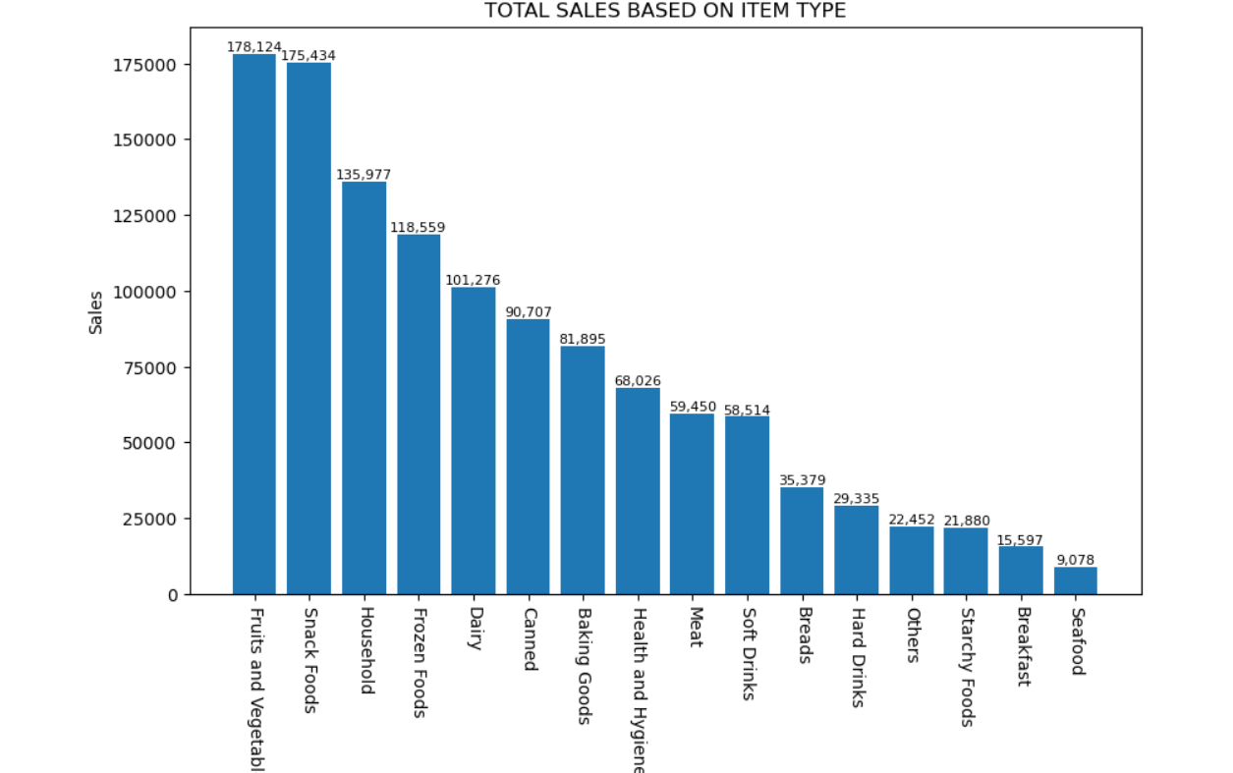

**7)TOTAL SALES BASED ON ITEM TYPE:**

grouped=df.groupby(['Outlet Location Type','Item Fat Content'])['Sales'].sum().unstack()

grouped=grouped[['Low Fat','Regular']]

plot=grouped.plot(kind='bar',figsize=(8,6),title='SALES BASED ON OUTLET LOCATION TYPE SEGMENTED BY FAT CONTENT')

plt.ylabel('Sales')

plt.show()

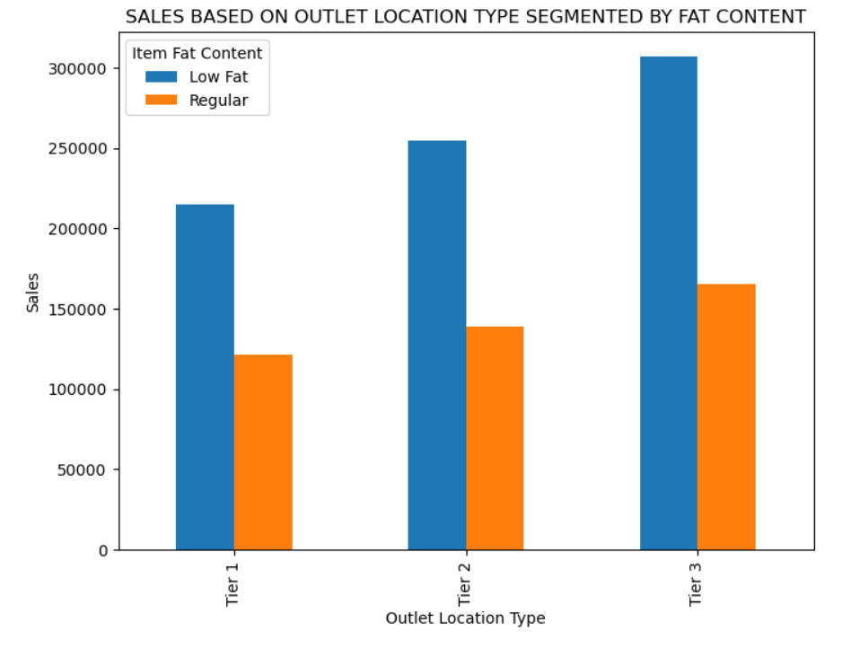

**8)TOTAL SALES BASED ON OUTLET ESTABLISHMENT YEAR:**

SALES_BASED_ON_ESTABLISHMENT_YEAR=df.groupby('Outlet Establishment Year')['Sales'].sum().sort_index()

plt.figure(figsize=(8,5))

line_plot=plt.plot(SALES_BASED_ON_ESTABLISHMENT_YEAR.index,SALES_BASED_ON_ESTABLISHMENT_YEAR.values,marker='o',linestyle='-')

plt.xlabel('Outlet Establishment Year')

plt.ylabel('Sales')

for x,y in zip(SALES_BASED_ON_ESTABLISHMENT_YEAR.index,SALES_BASED_ON_ESTABLISHMENT_YEAR.values):

plt.text(x,y, f'{y:,.0f}',fontsize=8,ha='center',va='bottom')

plt.tight_layout()

plt.title('SALES BASED ON OUTLET ESTABLISHMENT YEAR')

plt.show()

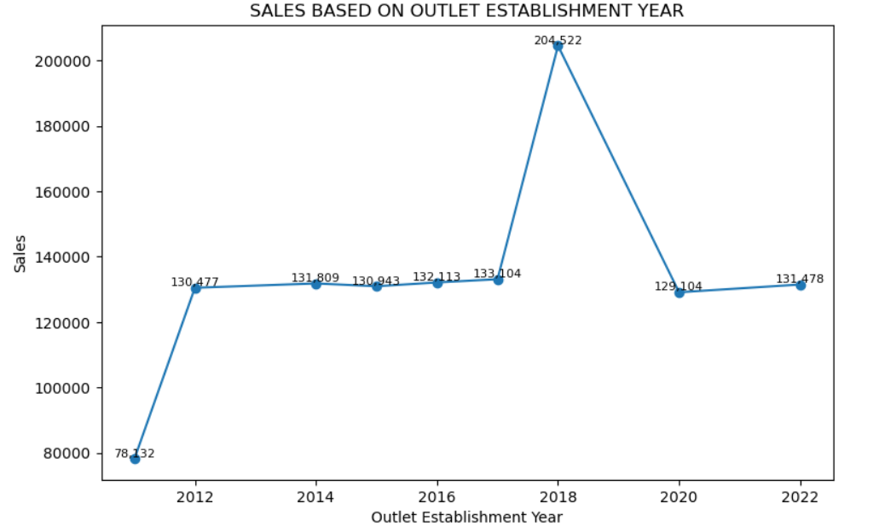

**9)TOTAL SALES BASED ON ITEM TYPE:**

total_sales_based_on_outletsize=df.groupby('Outlet Size')['Sales'].sum()

def total_value(val):

total_sum=sum(total_sales_based_on_outletsize)

sum_value=int(round(val*total_sum/100))

return f"${sum_value:,}"

plt.pie(total_sales_based_on_outletsize,labels=total_sales_based_on_outletsize.index,

autopct=total_value,

startangle=90)

plt.axis('equal')

plt.title('SALES BASED ON OUTLET SIZE')

plt.show()

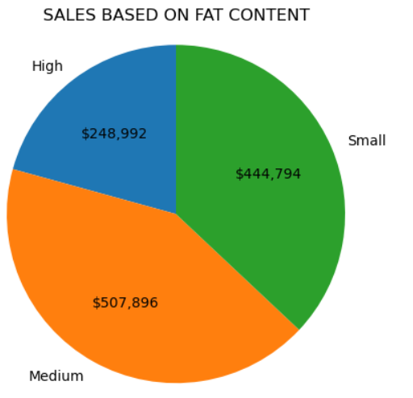

**10)TOTAL SALES BASED ON OUTLET LOCATION:**

**USING MATPLOTLIB:**

TOTAL_SALES_BASED_ON_OUTLETTYPE=df.groupby('Outlet Type')['Sales'].sum().sort_values(ascending=False)

plt.figure(figsize=(8,6))

bars=plt.bar(TOTAL_SALES_BASED_ON_OUTLETTYPE.index,TOTAL_SALES_BASED_ON_OUTLETTYPE.values)

plt.xlabel('Outlet Type')

plt.ylabel('Sales')

plt.title('SALES BASED ON OUTLET TYPE')

for bar in bars:

plt.text(bar.get_x()+bar.get_width()/2,

bar.get_height(),

f'{bar.get_height():,.0f}',

va='bottom',

ha='center',

fontsize=10

)

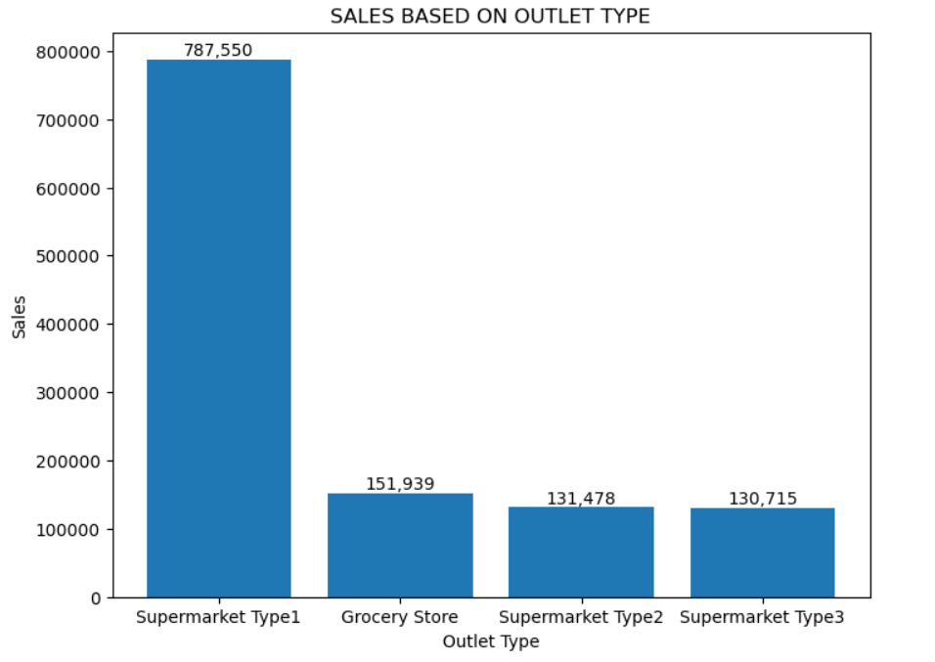

**USING SEABORN:**

TOTAL_SALES_BASED_ON_OUTLETTYPE=df.groupby('Outlet Type')['Sales'].sum().sort_values(ascending=False)

df_outlet = TOTAL_SALES_BASED_ON_OUTLETTYPE.reset_index()

df_outlet.columns = ['Outlet Type', 'Sales']

plt.figure(figsize=(8,6))

bars=sns.barplot(data=df_outlet, x='Outlet Type', y='Sales')

plt.xlabel('Outlet Type')

plt.ylabel('Sales')

plt.title('SALES BASED ON OUTLET TYPE')

for bar in bars.patches:

plt.text(bar.get_x()+bar.get_width()/2,

bar.get_height(),

f'{bar.get_height():,.0f}',

va='bottom',

ha='center',

fontsize=10

)

